**JSP Course**

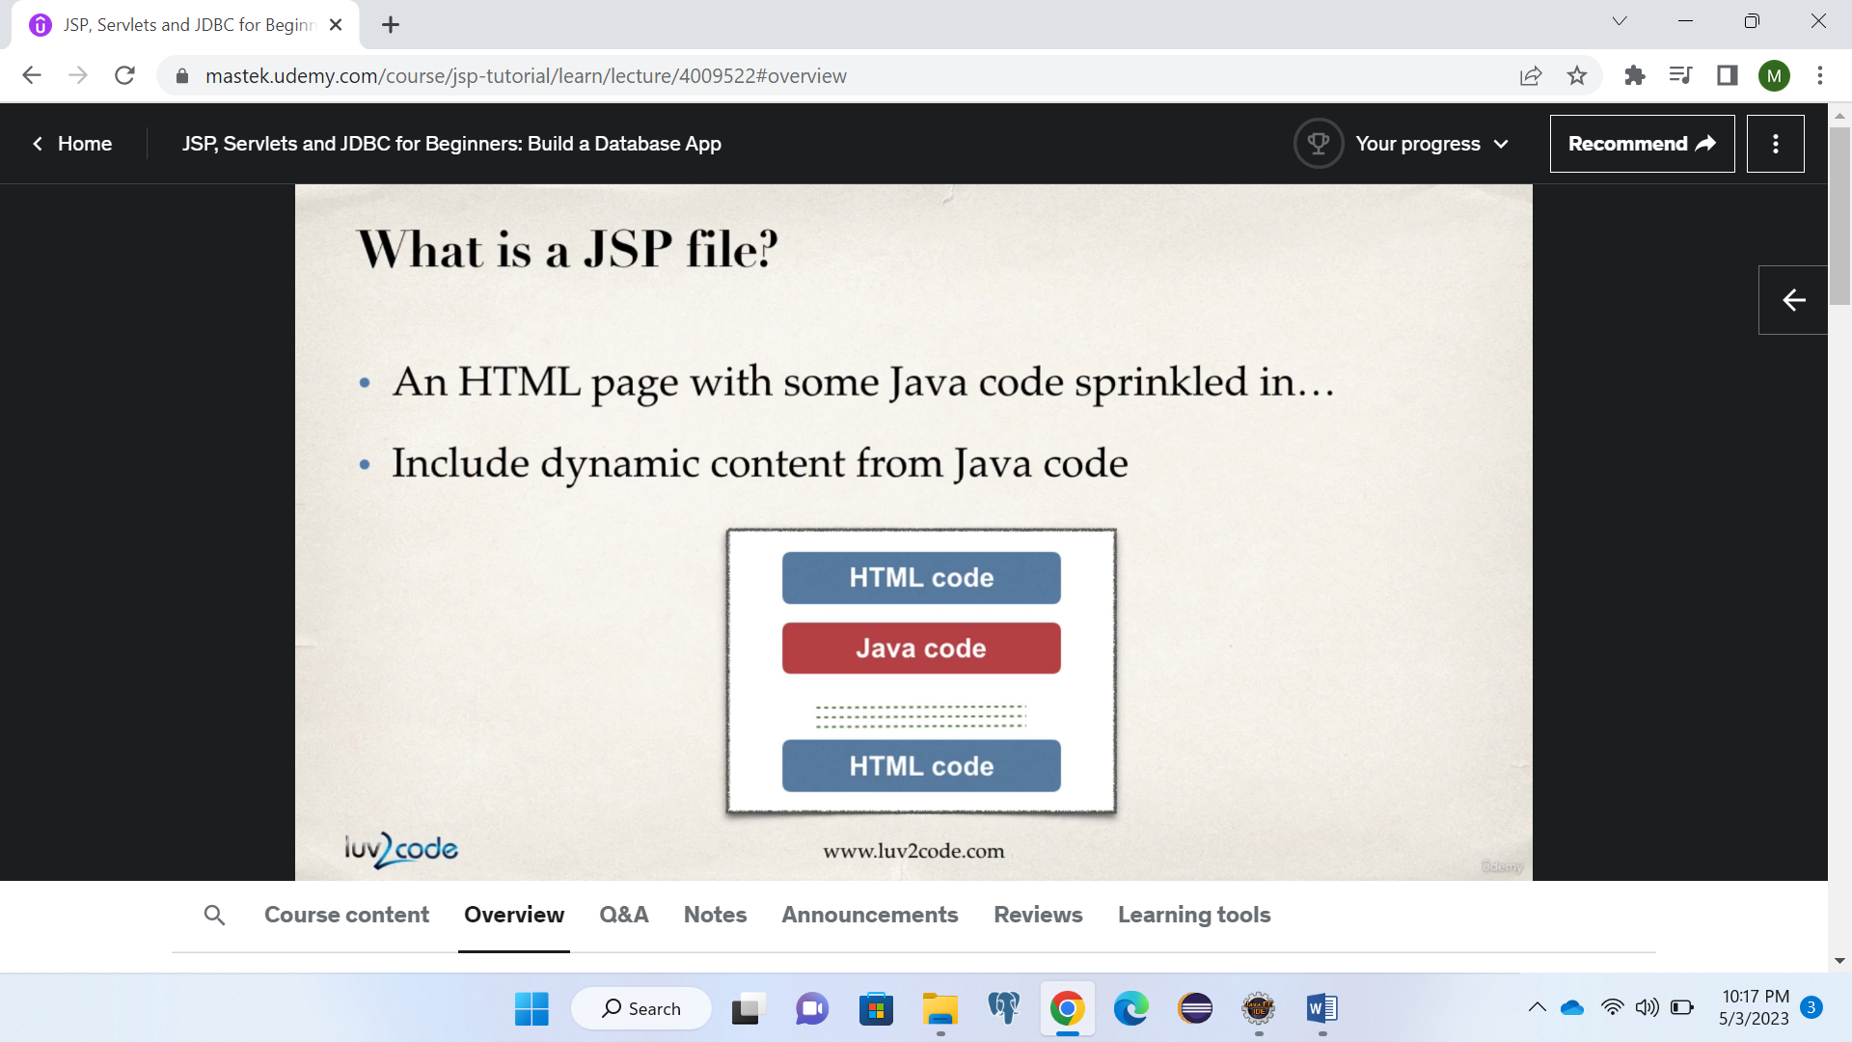

**Where is JSP Processed?**

JSP is processed at the tomcat server and result is returned as html page.

**Java Expression**

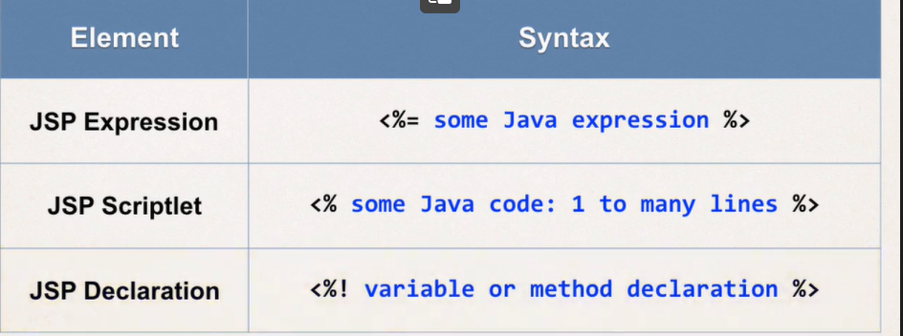

**Best practice scriplet**

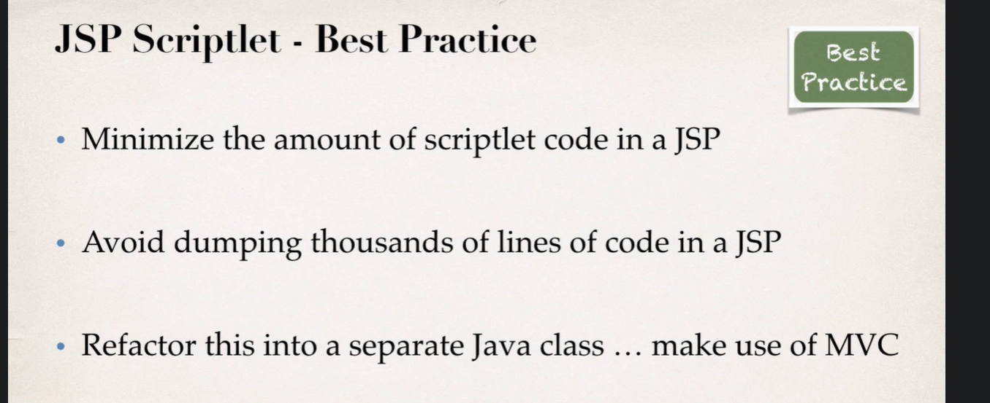

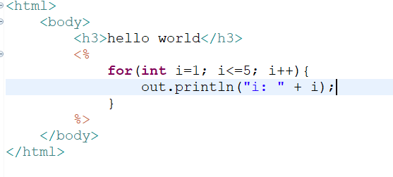

**JSP Declarations**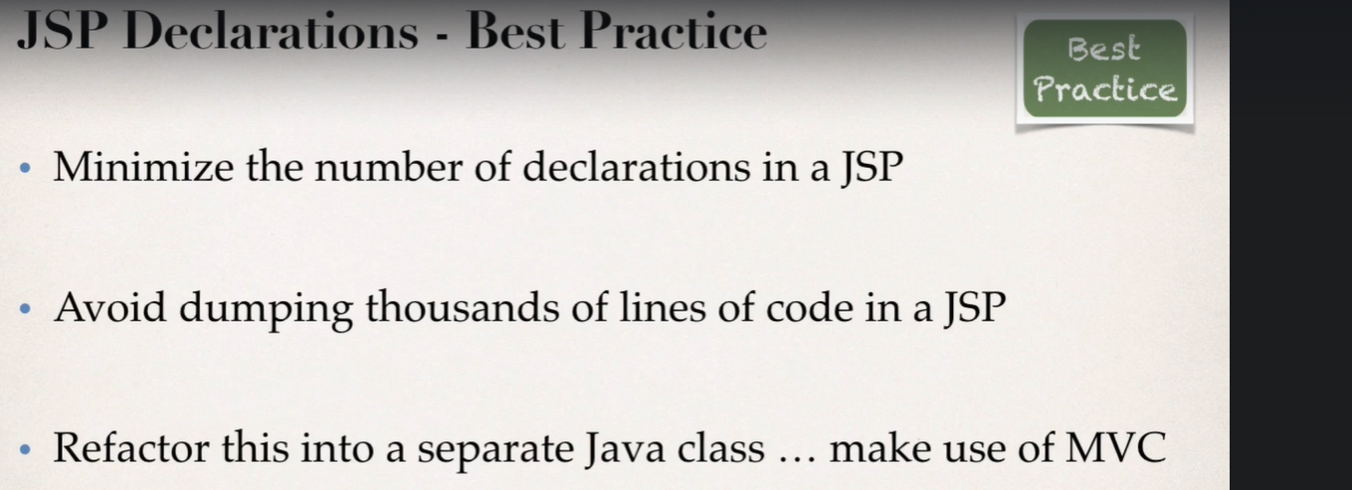

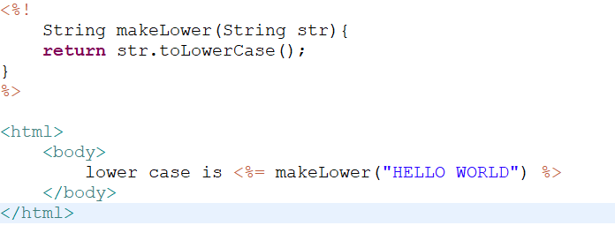

**Call java class from jsp**

**Method 1:**

<html>

<body>

Let have some fun <%= com.jspdemo.jsp.UtilFunctions.makeLower("HELLO") %>

</body>

</html>

**Method 2:**

<%@ page import=*"com.jspdemo.jsp.UtilFunctions"* %>

<html>

<body>

Let have some fun <%= UtilFunctions.makeLower("HELLO") %>

</body>

</html>

**Built-In Server Objects**

